KOREAN CINEMA NOW
Monthly series presented in cooperation with The Korea Society

Bleak night (Pasuggun)
Sunday, May 22, 7:00p.m.

2011, 116 mins. Written, directed, and edited by Yoon Sung-hyun. Produced by Korean Academy of Film Arts. Photographed by Byun Bong-sun. Production design by Kang Yung-soo.
Principal cast: Lee Je-hoon (Gi-Tae), Seo Jun-young (Dong-Yoon), Park Jung-min (Baek Hee-Joon), Jo Sung-ha (Hi-Tae’sfather), Bea Je-ki (Jae-Ho), and Lee Cho-hee (Se-Jung).

Yoon Sung-hyun interview with Park Soo-mee for The Hollywood Reporter, March 23, 2011:

Yoon Sung-Hyun’s Bleak Night opens with teenage schoolboys beating their friend in an empty lot near an urban train track. In the following scenes, audiences are taken on an intense journey of a father trying to figure out the death of his son. The writer-director of this coming-of-age film about three high-school friends is a 29-year old Yoon Sung-Hyun, who made the film as a graduation project for the Korean Academy of Film Arts. In a rare occurrence for a debut feature, the film won the New Currents Award at last year’s Busan International Film Festival, competed at Rotterdam and was handpicked by CJ Entertainment for wide release. The Hollywood Reporter’s Seoul Correspondent Park Soo-mee recently met with Yoon, and discussed his film…
What kind of a film did you have in mind when you were filming Bleak Night?
I wanted to make a mystery-noire film at first. Later, as I brought the theme of “death,” the film’s direction started to change completely. Ultimately, the film is about death, human relationship and loneliness.
A number of Korean films delve into the traumas of boys’ schools and the notion of masculinity as in Friends and Once Upon a Time in High School. Did you grow up watching these films?
At first I just thought that a story set in high school would be interesting. I like coming-of-age stories of boys. A school is a small society and it’s an ideal setting to show how people relate to each other. Also, I grew up reading all kinds of comic books involving macho male students involved in fist fighting, although I didn’t particularly want to make those kinds of films.
In the film you don’t provide a clear reason about Ki-tae’s death and the opening scene is a trap in a way, because it complicates the audiences’ perception about who will die among those boys.
It’s a way to bring the audiences closer to the truth. Ki-tae’s character is portrayed very superficially in the film’s beginning. Ki-tae is an aggressor and he is far from death. But the film gets closer to his truth towards the end. When we see a father of a dead son in a film we naturally associate him as the victim. In this film, the audiences develop a different perspective of death as they learn that the dead one was the offender and not the victim. In telling the story, I felt that a suicide is not something one could judge based on certain preconceptions like the film’s opening scene, which leads the audiences to believe in certain way. I wanted the audiences to feel those emotional fragments of Ki-tae before he decided to end his own life…
Ki-tae is an extremely fragile character. He’s very defensive and he communicates in an aggressive manner like many Korean men who are exposed to an overtly macho culture, but he’s also very vulnerable. He wants his identity to be present among his friends. In the film, Ki-tae demands assurances of his friends that he is the strongest in the group. Much of the Korean society works in a similar way, and that’s why many people obsess over someone’s background and believe that their social titles equal their identity. I wanted to illustrate the motives of Ki-tae’s defense mechanism. It was important for the audiences to understand his emotional state, and if you see the film closely, the reason [for Ki-tae’s death] is clear.
It’s also vague why Ki-tae and his friends end up being so hostile to each other...
Friends become enemies for such petty reasons. Dilemmas between lovers or family members really come down to an individual’s trauma. Some minor issues are often expanded. Like death, such dilemmas need to be explained more voluminously.
The actors were stunning in the film. Did you do the casting by yourself?
I did. I met Ki-tae on another set for a short film. Later, I approached him while writing the script. Dong-yoon was a child actor. I liked his image from the photo. Hee-joon auditioned for the role after I saw him in a short film.
Did Ki-tae find it difficult to understand his role? What were your specific directions for his acting?
He got the feel of the character quite well. It wasn’t a difficult story for him. I think most Korean men identify with Ki-tae’s role. At some point we all go through emotional dilemmas that Ki-tae went through. Many directors and friends that I thought were macho reacted most fervently to the film. My only direction for Ki-tae was his way of talking. Actors hate it when directors comment on their way of talking, because they’re memorizing the lines in their head. It was difficult, because acting is reaction, not action and the best acting comes through when he or she listens through their heart.
Did you grow up watching a lot of films?
I did. When I was young I used watch all the cliché films that boys love like Alien and Blade Runner by Ridley Scott and James Cameron’s Terminator. But the film that shocked me the most was Raining Stones by Ken Loach. The characters were live in the film. He doesn’t give a lot of explanation but I just get him. I also admire films of Gus Van Sant, especially his Elephant. His narrative style is revolutionary. I learn from Ken Loach’s understanding of humanity, and Van Sant’s narrative construction and other formal experiments. I think they both question core issues of humanity. Is there a law and God? Their narrative on reality always amazes me.
Bong Joon-ho raved about your film [Bong called Bleak Night “a well-made film that cools your liver and gall”] recently.
I respect him immensely. Like Bong I, too, want to be a film master. You can’t depend on reviews or public reactions as a filmmaker. Many of them simply make it because they’re lucky. I was lucky. But ultimately, I want to make a film as if I was making pottery. I want to be satisfied with every piece of pottery I make and be better at it every time. For me, Bong Joon-ho is one of those masters. He always moves forward.
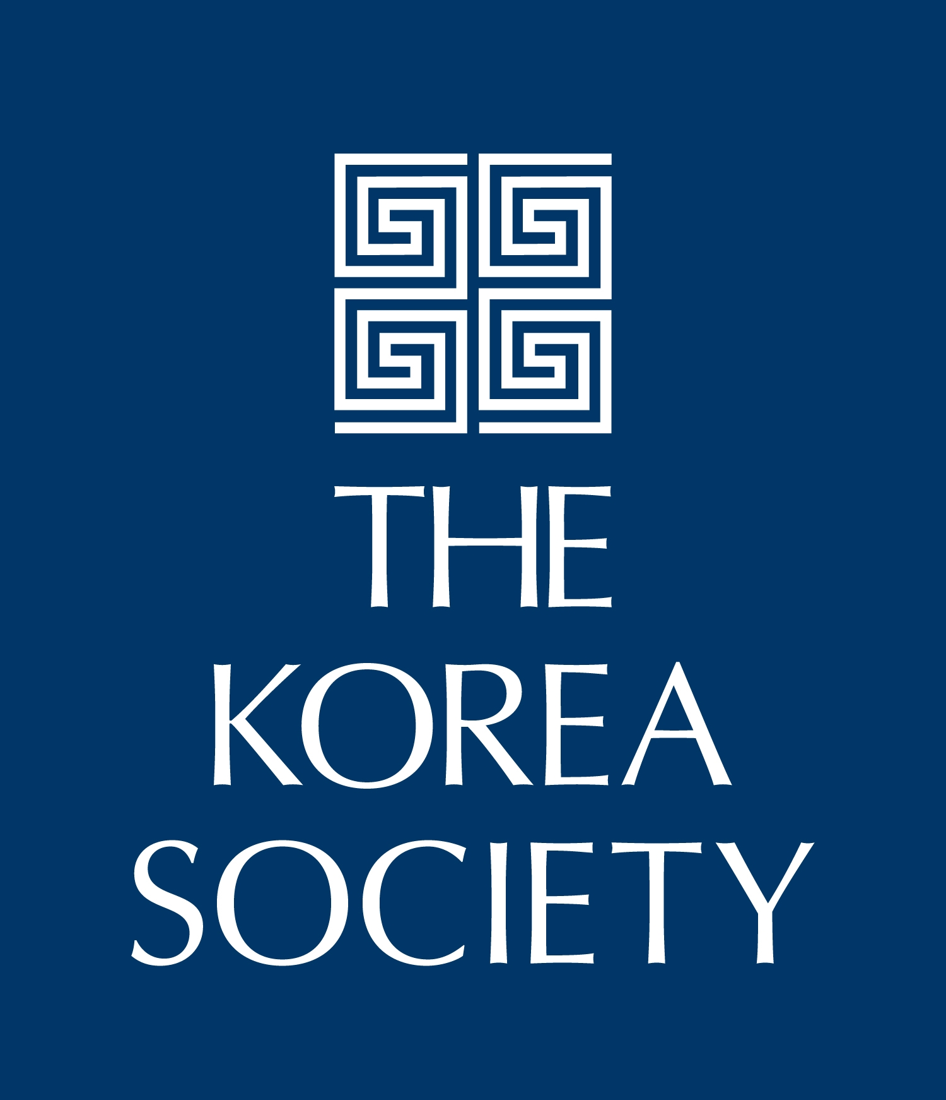

Museum of the Moving Image is grateful for the generous support of numerous corporations, foundations, and individuals. The Museum is housed in a building owned by the City of New York and receives significant support from the following public agencies: the New York City Department of Cultural Affairs; New York City Economic Development Corporation; New York State Council on the Arts; Institute of Museum and Library Services; National Endowment for the Humanities; National Endowment for the Arts; Natural Heritage Trust (administered by the New York State Office of Parks, Recreation and Historic Preservation).

Copyright © 2011, Museum of the Moving Image

