KOREAN CINEMA NOW

Monthly series presented in cooperation with The Korea Society

HAHAHA
Sunday, February 20, 2011, 6:00 p.m.

2010, 115mins. 35mm print.

Written and Directed by Hong Sang-soo. Produced by Kim Kyoung-hee. Photographed by Hongyeol Park. Edited by Sungwon Hahm. Music by Jeong Yong-jin.
Principal cast: Kim Sang-kyung (as Jo Mun-kyung), Moon Sori (Wang Seong-ok), Yu Jun-sang (Bang Jung-shik).

Review by Hur Moon-young, film critic and director of Busan Cinematheque.

One summer, two friends Mun-kyung and Jun-shik each travel to Tongyeong, a small town in Korea. Not crossing each other at the place, they encounter a couple of ladies there and the two men returning to Seoul recollect their memories of their summer journey over drinks. HaHaHa, the tenth feature film by Hong Sang-soo, shares the motives of his past works; man’ s travels, accidental encounters with unknown women, and courtship. But it reveals a more colorful texture than his past works, full of warm sentiments and vitality. Undrawn by any abstract order or concept but endlessly advancing into a world of contingency and mystery created by specific emotions and matters, Hong has united a new combination of aesthetics and ethics by engaging a difficult question of responsibility and choice in this film.

Hong’s characters now go further than being captivated desires or anxieties and attempt to take on the responsibilities of their lives’ journeys. Mun-kyung asks the woman he courts to marry him and Jung-shik who is a married man tries the best he can for his lover who accompanies him. Of course fate does not grant them favors for taking on the responsibilities. Figuratively speaking fate is a painting without a frame and a personal decision is merely a smear. One of the interesting points about HaHaHa is that it captures the relationship between personal decision and fate with a form of reminiscences and narratives.

The storyline of the film looks as through it’s composed of two men’s crossed flashbacks, but in the actual narrative, the incidents out of two men’s perspectives form significant ties. For instance, the new apartment bought by Mun-kyung’s mother falls into the hands of his rival love, outside Mun-kyung’s eyes and decision. His decision to take on responsibility becomes a blank gesture, and the reminiscence pushes forward with its own force, leaving out the principal of the reminiscence. The black and white stilled images of the principal of the reminiscence making the recollection is not just a metrical technique. Surprisingly, the most touching moments in the film are when they make those empty decisions, in other words, when the unexpectedness and naivety leaves behind a smear.

If HaHaHa is selected as Hong’s major film, it won’t be just for its delicate structure or intellect, as the film is the finest among his works. Its beauty is not something like minor chords sang from a world that continues without its principals, but more closer to the vitality from personal determination of someone taking on responsibility like glittering porcelain chips glittering within the darkness of the world. HaHaHa is fluid and harmonious like excellent music, but unlike music, is vibrant through the energies of specific matters.

Excerpt from “Hong Sang-soo: Modern Mastery,” Richard Brody, The New Yorker, February 9, 2011:

In discussing Joseph Mankiewicz’s delicious 1949 romantic (and comic) drama A Letter to Three Wives, I call attention to its exquisite construction, which is both straightforward (four framing scenes with three long flashbacks between them—think of the spaces between four spread fingers) and intricate (in its interweaving of the voice-over of the unseen protagonist—the author of the letter—into the frame, and in the interweaving of dramatic threads through the flashbacks). If it makes sense to think of a night-table movie, one that I often come back to, with familiar delight and ever-new admiration, A Letter to Three Wives is at the top of the pile.

I’ve had my eye on Hong for only five years, since I saw Woman Is the Future of Man and knew, from the very first shot, that he’s a true and rare artist, and I’ve kept up with as many films of his as we’ve been able to get hold of here…Some people have compared his films to those of Eric Rohmer; other, wiser heads, acknowledging the quasi-autobiographical nature of his films (many of which are set in the world of filmmaking), have likened him to Jean Eustache. But after seeing HaHaHa, I was struck by his similarities with Mankiewicz.
HaHaHa is also a film of flashbacks from multiple perspectives. The setup concerns two old friends who meet at a bar and discuss their romantic experiences in a small city they were both visiting at the same time. The frame shows them in black-and-white photographs, their reminiscences coming in voice-overs, which are punctuated by their hearty “Cheers,” as, with each drink, they go deeper into their stories. But, remarkably, the story told in flashbacks is actually that of the romances of three men—one, a filmmaker, tells a story that’s his own; his friend tells both his own story and that of a mutual acquaintance whose girlfriend, as it turns out, is the woman the filmmaker was pursuing…
…Hong’s puts its elaborate device of memory to direct, strongly emotional ends; it’s a surprisingly funny film (as the title suggests) about the pain of longing and the strange twists that unexpected love gives a life’s path.

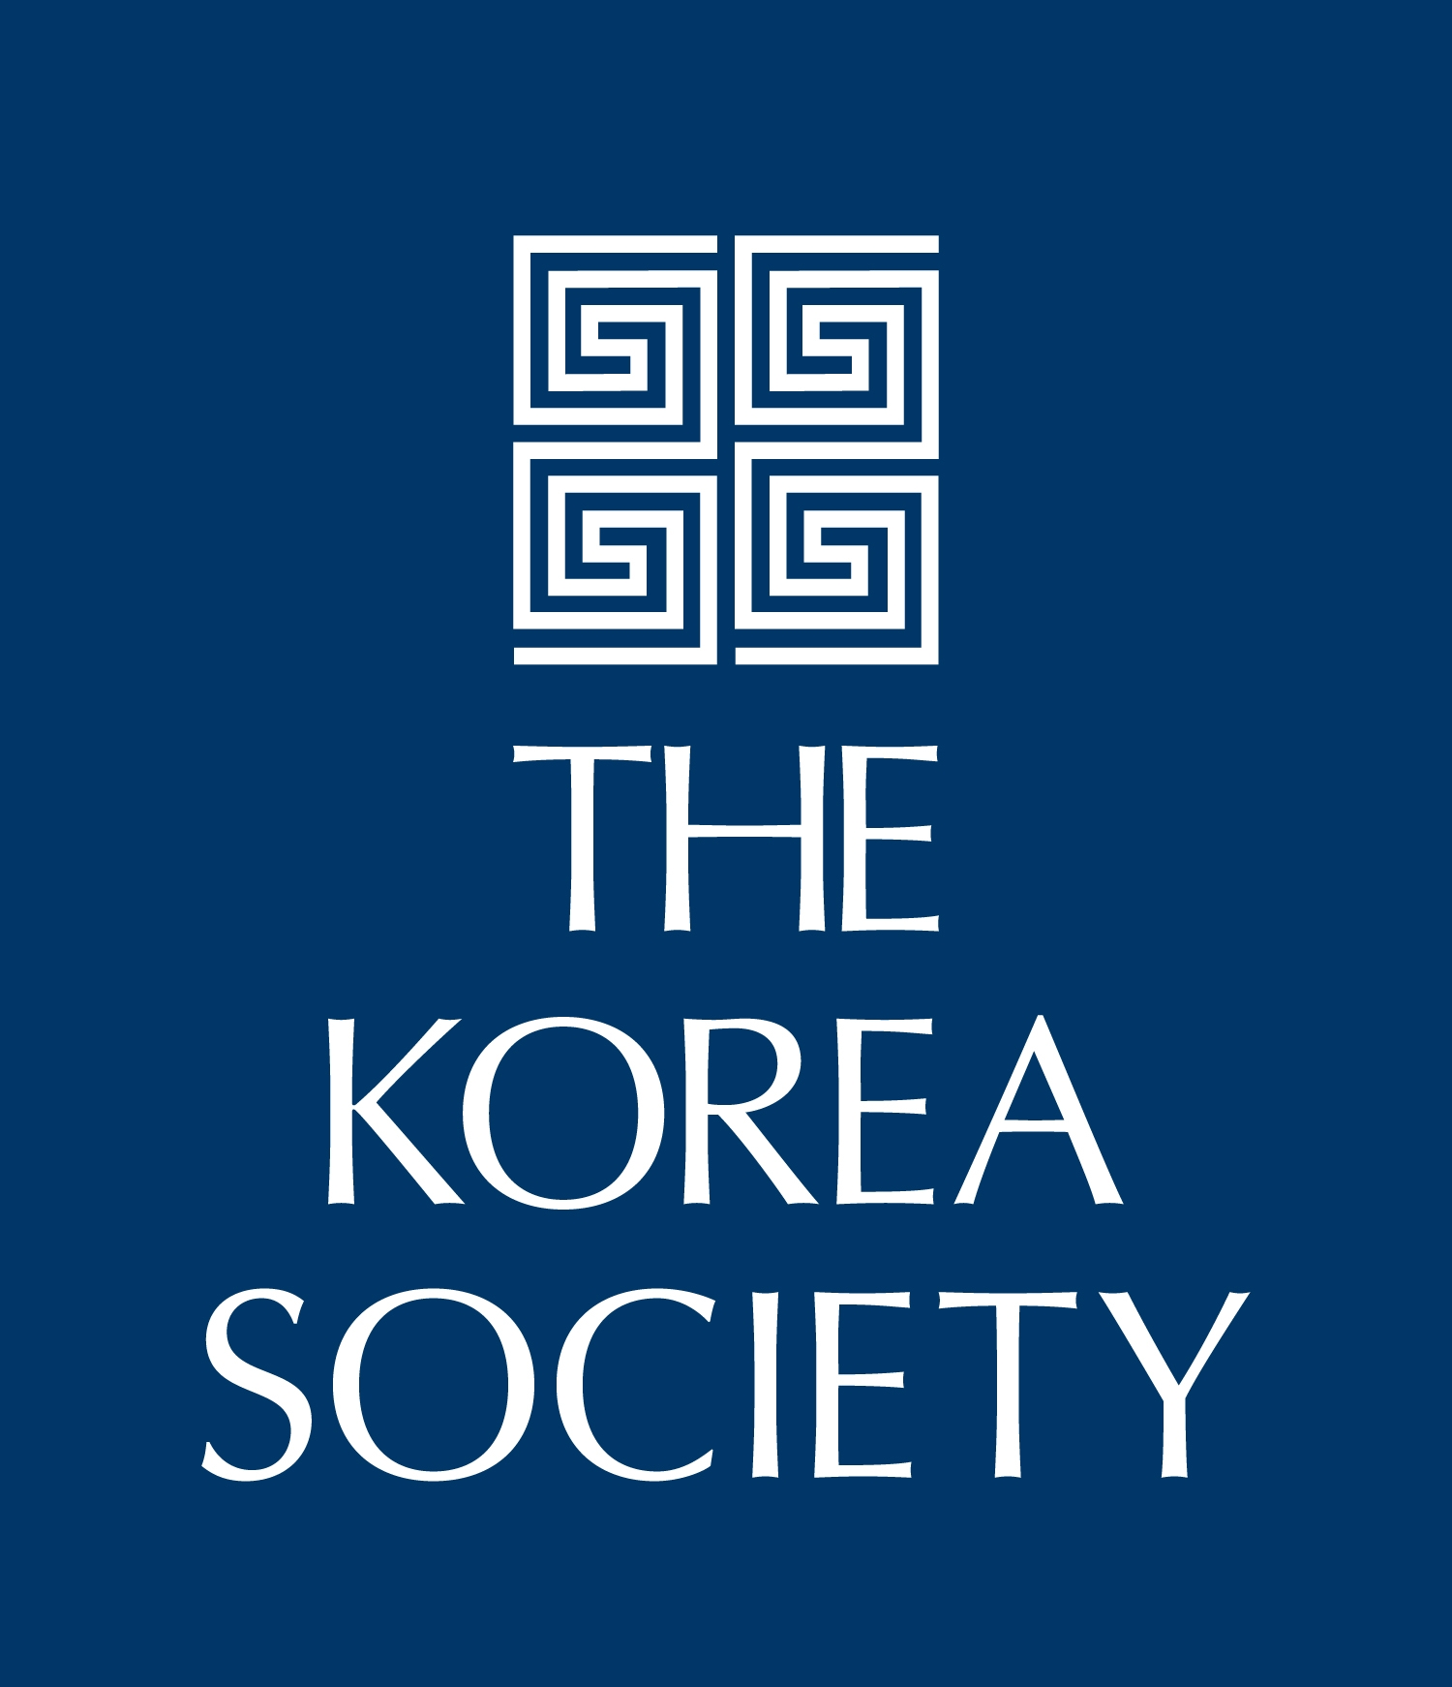

Museum of the Moving Image is grateful for the generous support of numerous corporations, foundations, and individuals. The Museum is housed in a building owned by the City of New York and receives significant support from the following public agencies: the New York City Department of Cultural Affairs; New York City Economic Development Corporation; New York State Council on the Arts; Institute of Museum and Library Services; National Endowment for the Humanities; National Endowment for the Arts; Natural Heritage Trust (administered by the New York State Office of Parks, Recreation and Historic Preservation).

Copyright © 2011, Museum of the Moving Image

