FASHION IN FILM FESTIVAL:
BIRDS OF PARADISE
April 15—24, 2011

steven arnold special
Friday, April 22, 7:00 P. M.
Introduced by Stuart Comer, Curator of Film, Tate Modern (London).

Stuart Comer is Curator of Film at Tate Modern, London. He oversees film and video work for the Tate Collection and Displays and organizes an extensive program of screenings, forums, and lectures focusing on current cultural issues and the history of artists’ film and video. He has contributed to numerous publications and periodicals, including Artfoum, Frieze, Afterall, Parquett, and Art Review. Recent freelance curatorial projects include ‘Andy. As you know I am writing a movie…’ at Beirut Art Center and the 2007 Lyon Biennial.

About Steven Arnold:

“Creator of these Baroque Tableaux is an artist who exercises his birthright, which is the expression of his own particularity of vision. A vision thrust forward by the agitation deep beneath the recesses of his chthonic cave. The cave ceiling lined with broken bits of reflecting devices in which we see new angles of men, of women, of glamour, angels, beauty, sex, fabrication, androgyny and exultation.”
–Ellen Burstyn

The artist, photographer and filmmaker Steven Arnold was a muse and model of Salvador Dalí who always referred to Arnold as his prince. Andy
Warhol star Holly Woodlawn claimed that if Warhol’s Factory was typical New York, then the circle around Arnold in Los Angeles was Versailles.

Arnold’s work provides a fascinating bridge between the early cross-gender experiments of Claude Cahun and Pierre Molinier and what the media theorist Gene Youngblood termed the
“polymorphous subterranean world of unisexual transvestism” that he saw as a hallmark of the emerging “synaesthetic cinema” of the 1960s.

The screening also pays homage to an innovative—yet often overlooked—poet of the Beat Generation, ruth weiss, who stars in all the films featured. weiss worked with Arnold in the late-1960s, and among many other jobs she did to support her writing career, was that of a chorus girl.

All films are digital restorations, courtesy The Steven Arnold Archive, Stephanie Farago, Director.

Various Incarnations of a Tibetan Seamstress
1969. 10 mins.
With ruth weiss, Pat Eddy Lowe, Stephen Kelemen. Costumes by Steven Arnold.
Originally, it was to be a serious look at Westerners influenced by Eastern trends. As it developed, however, it became much more humorous, with characters in yoga positions with high heels and smoking cigarettes at the same time.” —Stephanie Farago

Messages, Messages
1972. 23 mins.
With ruth weiss, The Joseph, Pandora. Costumes by Steven Arnold.
A journey of the psyche into the world of the unconscious. Made when Arnold and I were students at the San Francisco Art Institute, the film is influenced by Dali, Buñuel, and the German expressionists.” —Michael Wiese
The Liberation of the Mannique Mecanique
1967. 15 mins.
With Sonia Magill, ruth weiss. Costumes by Steven Arnold.
Loosely based on William A. Seiter’s 1948 film One Touch of Venus, Steven Arnold’s first film is a macabre, decadent work presenting mannequins and models that travel through strange universes.

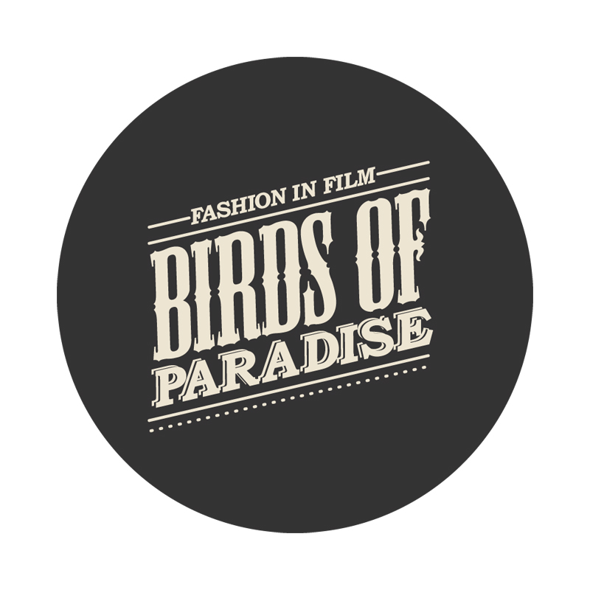

Fashion in Film is an exhibition, research, and education project based at Central Saint Martins College of Art and Design, University of the Arts London. Birds of Paradise, Fashion in Film’s second collaboration with Museum of the Moving Image, was organized in partnership with Yale University, the Center for the Humanities, and the Graduate Center at the City University of New York. The program was curated by Marketa Uhlirova, with assistance from Ronald Grogg, Stuart Comer, Eugenia Paulicolli, and Inga Fraser, and organized for Moving Image by Chief Curator David Schwartz.

Museum of the Moving Image is grateful for the generous support of numerous corporations, foundations, and individuals. The Museum is housed in a building owned by the City of New York and receives significant support from the following public agencies: the New York City Department of Cultural Affairs; New York City Economic Development Corporation; New York State Council on the Arts; Institute of Museum and Library Services; National Endowment for the Humanities; National Endowment for the Arts; Natural Heritage Trust (administered by the New York State Office of Parks, Recreation and Historic Preservation).

Copyright © 2011, Museum of the Moving Image

